Question 8:
Create a dictionary of five apps and their ratings. Use if-else to check whether WhatsApp is in the dictionary.
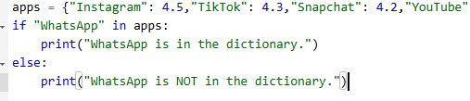
Output:
